# CS 340 README Project Two

**Describe the required functionality.**

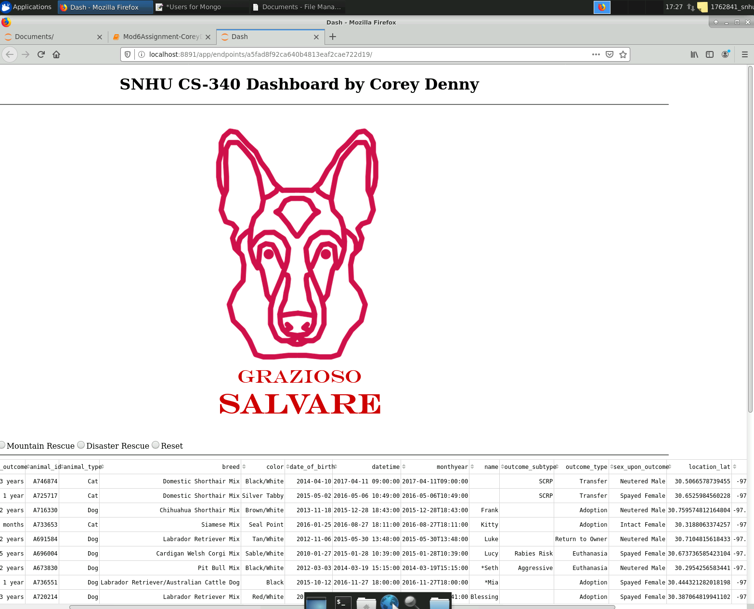

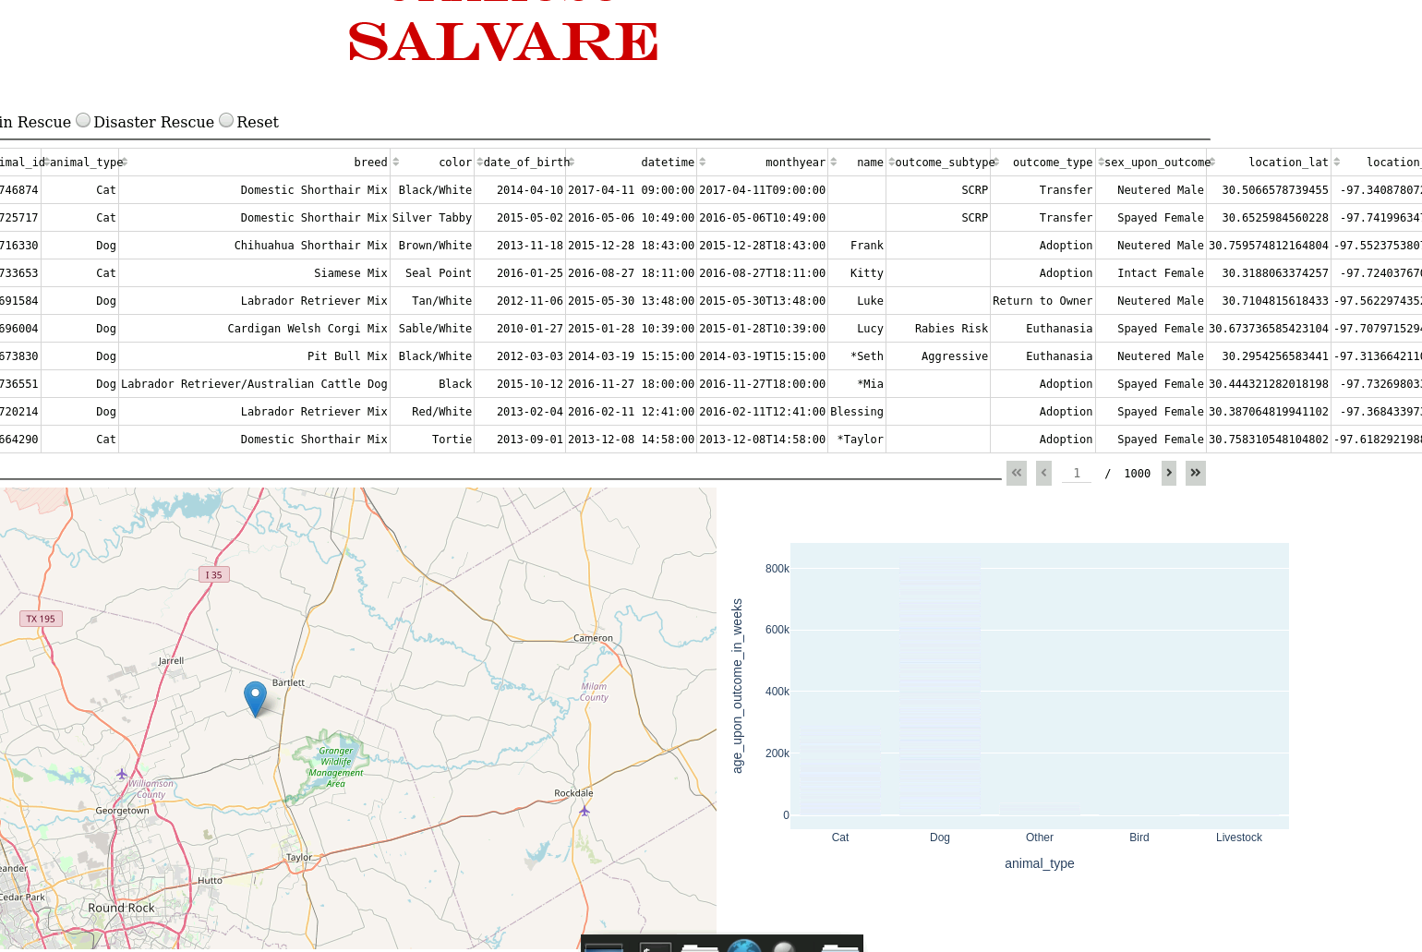

**I am not including screenshots of the different filters for different rescues because these filters are currently not working properly. There is preliminary code, but it is not functional. Also, the bar graph used is working properly but the colors are not. It is difficult to see the bars, but they are there.**

**Describe the tools used to achieve this functionality and a rationale for why these tools were used.**

**MongoDB is a NoSQL database that works well for storing a vast amount of data in a non-linear function.** PyMongo is a Python distribution containing tools for working with MongoDB, and is the recommended way to work with MongoDB from Python. PyMongo makes is fast and simple to work directly with a mongo database from an outside source. Dash is Python framework for building web applications. It built on top of Flask, Plotly.js, React and React Js. It enables you to build dashboards using pure Python. Dash is open source, and its apps run on the web browser.

<https://plotly.com/dash/>

<https://docs.mongodb.com/manual/installation/>

**Explain the steps that were taken to complete the project.**

**Jupyter Notebook is used to run the ipynb file. This file is coded in python and when run, displays output like a web browser. To complete this project, there are many steps. The first step is to create and test CRUD functions in python that work with the mongodb database. Once these functions have been created and tested, they will need to be implemented in the dashboard code. The next step is to import the necessary classes into the project. After this has been done, instantiation of the csv file is needed. Next, creating a layout for the app is needed. This is where all the text, graphs, and map are coded in and their respective settings are modified. App callbacks are needed for each function to display the information established earlier.**

**Identify any challenges that were encountered and explain how those challenges were overcome.**

Everything about this project was a challenge to me. I had to relearn python at the same time as learning mongodb code. Connecting to the mongo server always gave me issues. The main issue I was never able to solve was how to use the AnimalShelter class I created to read in the csv file. I had to bypass this step by reading in the csv file and not using the mongo server. This made it impossible to use my CRUD functions I created earlier. I was not able to solve this issue.